

**Object Oriented Programming**

**ASSIGNMENT NO 3**

**SUBMITTED BY:**

Hasaan Ahmad SP22-BSE-017

**SUBMITTED TO: Sir Muzaffar Iqbal**

**Activity 1:**

package Lab3;

class Circle {

    private int radius;

    public Circle() {

        radius = 7;

    }

    public Circle(int r) {

        radius = r;

    }

    public void setRadius(int r) {

        radius = r;

    }

    public int getRadius() {

        return radius;

    }

    public void display() {

        System.out.println("radius = " + radius);

    }

    public double CalculateCircumference() {

        return 2 * 3.14 * radius;

    }

}

public class Runner {

    public static void main(String args[]) {

        Circle c1 = new Circle();

        c1.setRadius(5);

        System.out.println("Circumference of Circle 1 is: " + c1.CalculateCircumference());

        int r = c1.getRadius();

        Circle c2 = new Circle(r);

        c2.setRadius(5);

        System.out.println("Circumference of Circle 2 is: " + c2.CalculateCircumference());

    }

}

**Output:**

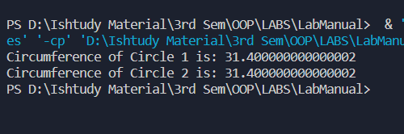

**Activity 2:**

package Lab3;

/**

 * Runner1

 */

public class Runner1 {

    public static void main(String[] args) {

        Rectangle1 rect = new Rectangle1();

        rect.setLength(5);

        rect.setWidth(10);

        System.out.println("Area of Rectangle is: " + rect.area());

        System.out.println("Width of Rectangle is: " + rect.getWidth());

    }

}

class Rectangle1 {

    private int length, width;

    public Rectangle1() {

        length = 5;

        width = 2;

    }

    public Rectangle1(int l, int w) {

        length = l;

        width = w;

    }

    public void setLength(int l) // sets the value of length

    {

        length = l;

    }

    public void setWidth(int w) // sets the value of width

    {

        width = w;

    }

    public int getLength() // gets the value of length

    {

        return length;

    }

    public int getWidth() // gets the value of width

    {

        return width;

    }

    public int area() {

        return (length * width);

    }

}

**Output:**

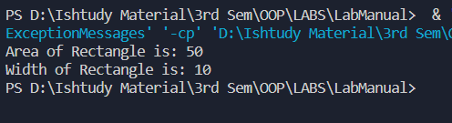

**Activity 3:**

package Lab3;

public class Runner2 {

    public static void main(String[] args) {

        Point p1 = new Point();

        p1.setX(10);

        p1.setY(7);

        p1.display();

        Point p2 = new Point(10, 11);

        p2.movePoint(2, 3);

        p2.display();

    }

}

class Point {

    private int x;

    private int y;

    public Point() {

        x = 0;

        y = 0;

    }

    public Point(int a, int b) {

        x = a;

        y = b;

    }

    public void setX(int a) {

        x = a;

    }

    public void setY(int b) {

        y = b;

    }

    public int getX() {

        return x;

    }

    public int getY() {

        return y;

    }

    public void display() {

        System.out.println("x coordinate = " + x

                + " y coordinate = " + y);

    }

    public void movePoint(int a, int b) {

        x = x + a;

        y = y + b;

    }

}

**Output:**

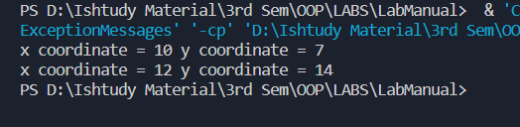

**Graded Lab Task 1:**

package Lab3;

/**

 * GLT1

 */

public class GLT1 {

    public static void main(String[] args) {

        Marks m1 = new Marks(90, 30, 50);

        System.out.println(m1);

        // m1.sciMarks cannot be accessed as it is declared privately

        m1.setMathMarks(90);

        System.out.println(m1.toString());

    }

}

class Marks {

    private int sciMarks;

    private int mathMarks;

    private int engMarks;

    public Marks() {

        sciMarks = 50;

        mathMarks = 50;

        engMarks = 50;

    }

    public Marks(int sciMarks, int mathMarks, int engMarks) {

        this.sciMarks = sciMarks;

        this.mathMarks = mathMarks;

        this.engMarks = engMarks;

    }

    public int getSciMarks() {

        return sciMarks;

    }

    public int getMathMarks() {

        return mathMarks;

    }

    public int getEngMarks() {

        return engMarks;

    }

    public void setSciMarks(int sciMarks) {

        this.sciMarks = sciMarks;

    }

    public void setMathMarks(int mathMarks) {

        this.mathMarks = mathMarks;

    }

    public void setEngMarks(int engMarks) {

        this.engMarks = engMarks;

    }

    @Override

    public String toString() {

    return "Marks [sciMarks=" + sciMarks + ", mathMarks=" + mathMarks + ",

    engMarks=" + engMarks + "]";

    }

}

**Output**

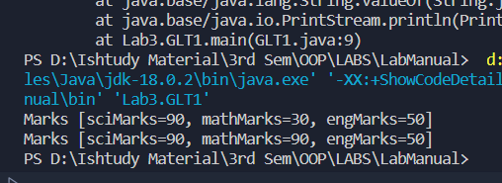

**Graded Lab Task 2:**

package Lab3;

public class GLT2 {

    public static void main(String[] args) {

        Account a1 = new Account(10000);

        System.out.println(a1.toString());

        a1.withdrawBalance(500);

        System.out.println(a1.toString());

        a1.depositBalance(1000);

        System.out.println(a1.toString());

        Account a2 = new Account(a1.getBalance());

        System.out.println(a2.toString());

    }

}

class Account {

    private int balance;

    public Account(int balance) {

        this.balance = balance;

    }

    public Account() {

        balance = 0;

    }

    void withdrawBalance(int amount) {

        balance -= amount;

    }

    void depositBalance(int amount) {

        balance += amount;

    }

    void setBalance(int balance) {

        this.balance = balance;

    }

    public int getBalance() {

        return balance;

    }

    @Override

    public String toString() {

        return "Account [balance=" + balance + "]";

    }

}

**Output**

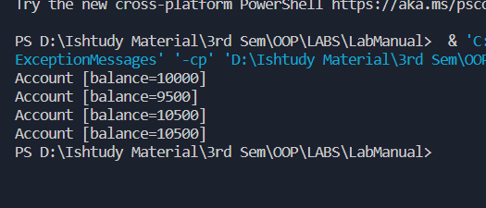

**Graded Lab Task 3:**

package Lab3;

public class GLT3 {

    public static void main(String[] args) {

        Student Hasaan = new Student("Hasaan Ahmad", new int[] { 10, 6, 7, 8, 9 });

        Hasaan.display();

        Student Mujtaba = new Student("Mujtaba", new int[] { 1, 2, 10, 10, 9 });

        Mujtaba.display();

        double avg1 = Hasaan.average();

        double avg2 = Mujtaba.average();

        if (avg1 > avg2) {

            System.out.println("Student 1 has greater average than student 2");

        } else if (avg2 > avg1) {

            System.out.println("Student 2 has greater average than student 1");

        } else {

            System.out.println("Both Students have same average");

        }

        Student hybrid = new Student(Hasaan.getName(), Mujtaba.getResult_array());

        hybrid.display();

    }

}

class Student {

    private String name;

    private int[] Result_array;

    public Student(String name, int[] result_array) {

        this.name = name;

        Result_array = result_array;

    }

    public double average() {

        int sum = 0;

        for (int i = 0; i < Result_array.length; i++) {

            sum += Result_array[i];

        }

        double average = sum / Result_array.length;

        return average;

    }

    public String getName() {

        return name;

    }

    public void setName(String name) {

        this.name = name;

    }

    public int[] getResult_array() {

        return Result_array;

    }

    public void setResult_array(int[] result_array) {

        Result_array = result_array;

    }

    void display() {

        System.out.println("Name: " + name);

        System.out.println("Average: " + this.average());

    }

}

**Output**

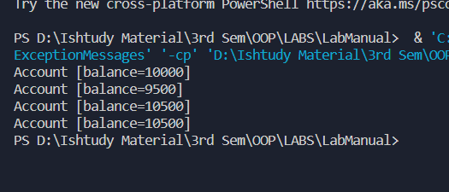

**Graded Lab Task 4:**

package Lab3;

public class GLT4 {

    public static void main(String[] args) {

        HotDogStand stand1 = new HotDogStand(1, 0);

        HotDogStand stand2 = new HotDogStand(2, 0);

        HotDogStand stand3 = new HotDogStand(3, 0);

        stand1.justSold();

        stand1.justSold();

        stand1.justSold();

        stand1.justSold();

        stand1.justSold();

        stand1.justSold();

        stand2.justSold();

        stand2.justSold();

        stand2.justSold();

        stand2.justSold();

        stand2.justSold();

        stand2.justSold();

        stand2.justSold();

        stand3.justSold();

        stand3.justSold();

        stand3.justSold();

        stand3.justSold();

        stand3.justSold();

        stand3.justSold();

        stand3.justSold();

        stand1.display();

        stand2.display();

        stand3.display();

    }

}

class HotDogStand {

    private int _uid;

    private int soldToday;

    public HotDogStand(int _uid, int soldToday) {

        this._uid = _uid;

        this.soldToday = soldToday;

    }

    public int get_uid() {

        return _uid;

    }

    public void set_uid(int _uid) {

        this._uid = _uid;

    }

    public int getSoldToday() {

        return soldToday;

    }

    public void setSoldToday(int soldToday) {

        this.soldToday = soldToday;

    }

    void justSold() {

        soldToday++;

    }

    void display() {

        System.out.println("ID : " + _uid);

        System.out.println("Sold Today: " + soldToday);

    }

}

**Output**

